PROJECT DOCUMENTATION

1.Introduction
• Project Title: AI FAQ Assistant
• Team ID:
• Team Leader: PORSELVI R(24csporselvi69@gmail.com )
• Team Members:
– POORNIMA L(24cspoornima68@gmail.com )
–PARVEEN A (24csparveen066@gmail.com )
–POOJA A(24cspooja067@gmail.com )
–PREMALATHA B (24cspremalatha70@gmail.com )

2.Project Overview
The AI FAQ Assistant is a web-based project that helps users find answers to frequently asked questions.The project is developed using Node.js and Express.js for the backend.The application stores FAQ details in MongoDB. Users can add, view, update, and delete FAQ questions and answers. It also uses Google Gemini AI to generate answers for the questions.For security, JWT authentication is used to protect the user account and private pages. Passwords are stored securely using bcrypt.

3. Main Technologies
- Node.js — JavaScript runtime for the backend.
- Express.js — REST API framework.
- MongoDB — NoSQL database.
- Mongoose — ODM for MongoDB.
- JWT — authentication for protected endpoints.
- bcrypt — password hashing.
- Google Gemini API — AI answer and FAQ generation.
- Thunder Client — API testing tool inside VS Code.
- Visual Studio Code — code editor.

4.Requirement
The project needs Windows 10 or 11, Node.js, npm, Express.js, and MongoDB to run properly.We also need Postman or Thunder Client to test the API. A code editor such as VS Code can be used to write and edit the project files.
Basic system requirement:
RAM – 8 GB
Free storage – around 1 GB
Windows 10/11

5. Project Folder
The project was located at:
C:\Users\porse\Downloads\Aifaq-main\Aifaq-main
Important: commands such as npm install and node server.js must be executed from the inner Aifaq-main folder where package.json is located.

6. Install Node.js
1. Install Node.js on Windows. Node.js v18 or above is suitable according to the project documentation.
2. Open PowerShell or the VS Code terminal.
3. check weather Node.js is installed by using:
node -v
4. To check the npm version use:
npm -v
During our setup the versions were Node.js v20.20.2 and npm 10.8.2.

7. MongoDB Installation and Setup
MongoDB is the database used by the project. The project documentation identifies MongoDB/Mongoose as the database layer.
1. Install MongoDB Community Server for Windows.
2 . During installation, select the option to run MongoDB as a Windows Service, if available.
3. After installation, verify the MongoDB service in PowerShell:
Get-Service MongoDB
The expected result is a MongoDB service with Status = Running.
4. If mongod is not recognized, temporarily add the MongoDB bin directory to the current PowerShell session:
$env:Path += ";C:\Program Files\MongoDB\Server\8.3\bin"
5. Check the MongoDB server executable:
mongod --version
6. After completing the installation, MongoDB is ready to be used by the project.

8. Project Installation
1. Open the project folder in VS Code.
2. Open the terminal inside the project folder.
3. Move to the correct project directory:
cd "C:\Users\porse\Downloads\Aifaq-main\Aifaq-main"
4. Install the project dependencies:
npm install
The installation completed successfully in our setup.

9. Environment Variables (.env)
Create a .env file in the project root. Do not share the real values of secrets or API keys.
PORT=5000
MONGO_URI=mongodb://127.0.0.1:27017/ai_faq_assistant
JWT_SECRET=your_private_jwt_secret
GEMINI_API_KEY=your_gemini_api_key
NODE_ENV=development
Meaning:
- PORT — backend server port.
- MONGO_URI — MongoDB database connection.
- JWT_SECRET — secret used to sign and verify JWTs.
- GEMINI_API_KEY — Google Gemini API key.
- NODE_ENV — application environment.
Do not put an individual login JWT token into .env. JWT_SECRET is the secret used to create/verify tokens; the token itself is generated during login.

10. Important Gemini API Issue We Solved
The original Gemini service used the @google/genai SDK. With the new AQ-style Gemini API key, the application returned 401 ACCESS_TOKEN_TYPE_UNSUPPORTED. We verified that the API key was loaded correctly and tested the key directly with the Gemini REST API. The direct request worked with gemini-3.6-flash and returned HTTP 200.
The Gemini service was therefore changed to use the REST API with the x-goog-api-key header and the gemini-3.6-flash model. This allowed the existing controllers and routes to remain unchanged.
Do not copy or publish the actual API key. Only keep it in the local .env file.

11. Starting the Backend Server
From the inner project directory:
node server.js
Expected output:
MongoDB Connected: 127.0.0.1
Server running in development mode on port 5000
The root health check can be opened in a browser:
http://localhost:5000
The project returned a successful API health response during testing.

12. Thunder Client Installation and Use
Thunder Client is a VS Code extension used to send HTTP requests and inspect JSON responses.
1. Open VS Code.
2. Open Extensions.
3. Search for Thunder Client.
4. Install the Thunder Client extension.
5. Open Thunder Client from the VS Code sidebar.
For protected endpoints, use Auth → Bearer Token and paste only the JWT token value. Do not add quotation marks and do not manually type the word Bearer.

13. User Registration Test
Request:
POST http://localhost:5000/api/auth/register
Body:
{
"name": "Test User 1",
"email": "test1@example.com",
"password": "Test@12345"
}
Expected: 201 Created with a success message and JWT token.
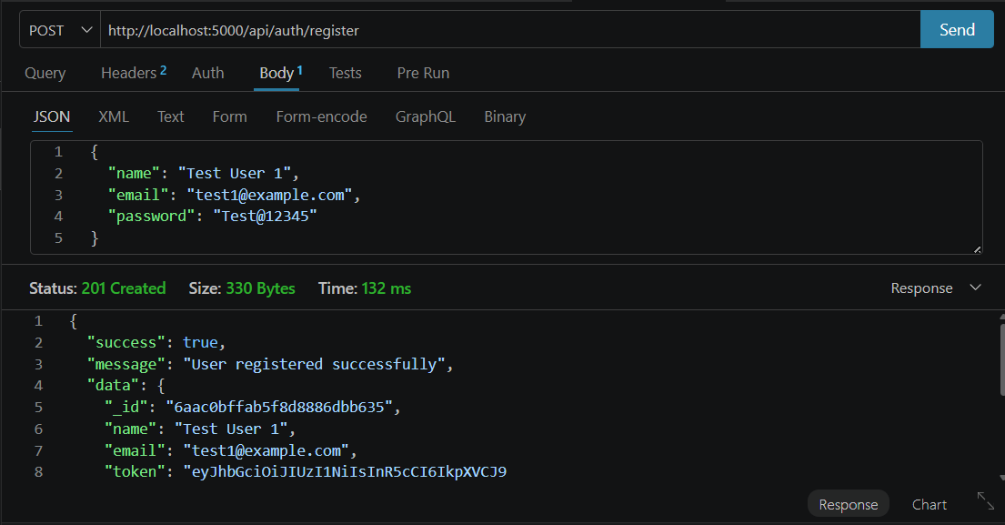

14. User Login Test
Request:
POST http://localhost:5000/api/auth/login
Body:
{
"email": "test1@example.com",
"password": "Test@12345"
}
Expected: 200 OK with a success message and a token. Copy the complete token directly from Thunder Client for later protected requests. Never share the token publicly.
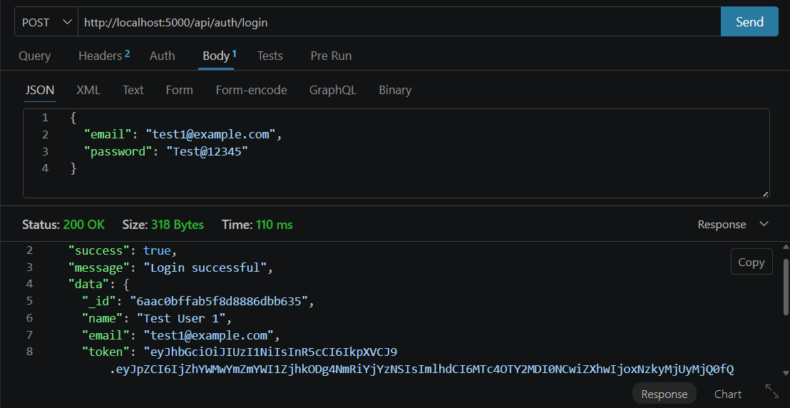

15. AI Answer Test
Request:
POST http://localhost:5000/api/ai/answer
Auth: Bearer Token → paste the fresh login JWT.
Body:
{
"question": "What is artificial intelligence?"
}
Successful result observed: 200 OK with success=true and an AI-generated answer.
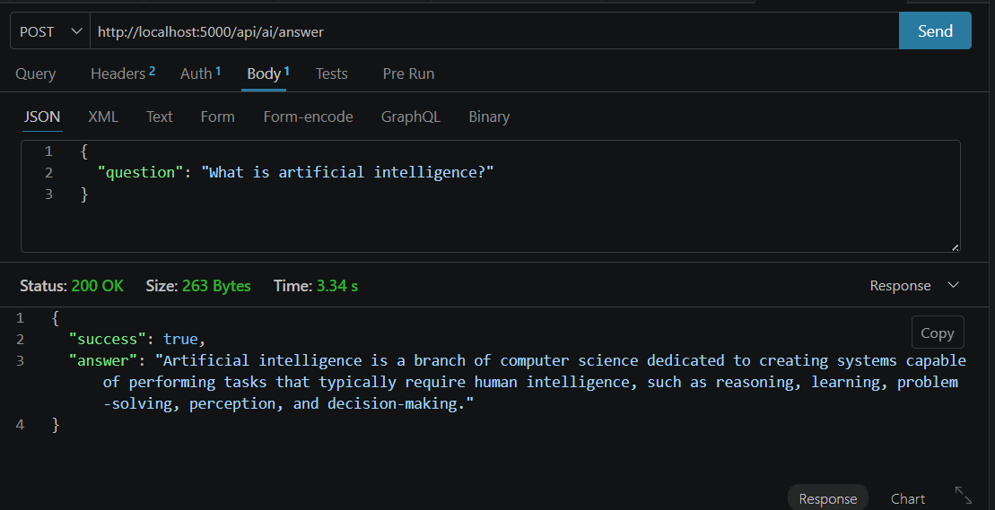

16. AI FAQ Generation Test
Request:
POST http://localhost:5000/api/ai/generate-faq
Auth: Bearer Token → paste the fresh login JWT.
Body:
{
"topic": "Artificial Intelligence"
}
Successful result observed: 200 OK with success=true, question, and answer.

17. FAQ Create Test
Request:
POST http://localhost:5000/api/faqs
Auth: Bearer Token → paste the fresh login JWT.
Body:
{
"question": "What is artificial intelligence?",
"answer": "Artificial intelligence is a branch of computer science that enables machines to perform tasks that normally require human intelligence.",
"category": "Technology"
}
Successful result observed: 201 Created and the FAQ was stored in MongoDB.

18. Get All FAQs Test
GET http://localhost:5000/api/faqs
The endpoint returned success=true, count=1, and the stored FAQ with creator information and timestamps during our test.

19. Update FAQ Test
Use the _id returned by the Create/Get All request. Example:
PUT http://localhost:5000/api/faqs/6aac17f4c1e56de6e3cd2d30
Auth: Bearer Token.
Example body:
{
"question": "What is Artificial Intelligence and how does it work?",
"answer": "Artificial Intelligence is a branch of computer science that enables machines to learn, reason, solve problems, and perform tasks that normally require human intelligence.",
"category": "Technology"
}
Expected: successful update response. In our testing, the update was completed successfully before deletion.

20. Delete FAQ Test
Use the FAQ _id:
DELETE http://localhost:5000/api/faqs/6aac17f4c1e56de6e3cd2d30
Auth: Bearer Token.
Successful result observed:
{
"success": true,
"message": "FAQ deleted successfully"
}

21. Search FAQ Test (Optional)
The project documentation defines the public search route as:
GET http://localhost:5000/api/faqs/search?q=configure
For the FAQ created during our test, an example query would be:
GET http://localhost:5000/api/faqs/search?q=artificial
Search was not executed in the final testing sequence because we proceeded directly to Update and Delete.

22. Complete API Testing Checklist
Endpoint | Purpose | Status
POST /api/auth/register | Register user | ✅ Tested
POST /api/auth/login | Login and receive JWT | ✅ Tested
POST /api/ai/answer | Generate AI answer | ✅ Tested
POST /api/ai/generate-faq | Generate FAQ using AI | ✅ Tested
POST /api/faqs | Create FAQ | ✅ Tested
GET /api/faqs | Get all FAQs | ✅ Tested
PUT /api/faqs/:id | Update FAQ | ✅ Tested
DELETE /api/faqs/:id | Delete FAQ | ✅ Tested

23. Common Problems and Fixes
Problem | Fix
npm.ps1 execution-policy error | Use a temporary PowerShell process policy if needed: Set-ExecutionPolicy -Scope Process -ExecutionPolicy Bypass
npm ENOENT / package.json not found | Make sure the terminal is inside C:\Users\porse\Downloads\Aifaq-main\Aifaq-main before running npm commands.
dotenv module not found | The command was run from the outer Aifaq-main folder. Change into the inner project folder.
Folder path is not recognized | Do not type a folder path by itself. Use cd "full\path\to\project".
Thunder Client Invalid URL | The HTTP method belongs in the method dropdown. The URL box should contain only http://localhost:5000/...
Connection refused | The Node server is not running. Start it with node server.js and keep the terminal open.
Not authorized, token failed | Login again and use the complete fresh JWT in Auth → Bearer Token without quotes or the word Bearer.
Gemini 401 ACCESS_TOKEN_TYPE_UNSUPPORTED | The original SDK call failed with the AQ key. Direct REST testing succeeded, so geminiService.js was changed to use REST/fetch and gemini-3.6-flash.

24. JWT Secret vs JWT Token
JWT_SECRET belongs in .env and is used by the server to sign/verify JWTs. The JWT token is generated after login and is sent in protected API requests.
JWT_SECRET=your_private_secret
If JWT_SECRET is changed, previously issued tokens will no longer verify. Restart the server and log in again to obtain a new token.

25. Project Architecture Summary
The project has three main parts:
Models – Manage database data.
Controllers – Handle the main project functions.
Routes – Handle user requests and API operations.
The project uses MongoDB to store data and Gemini AI for generating FAQ answers.

26. Important Security Notes
- Never share GEMINI_API_KEY.
- Never share JWT tokens in screenshots, GitHub repositories, or public messages.
- Keep .env out of Git commits by placing it in .gitignore.
- Use a strong, private JWT_SECRET.
- For deployment, configure environment variables in the hosting platform instead of hard-coding secrets.
- If a secret is accidentally exposed, rotate it.

27. Final Status
The project was successfully installed and tested.
The Node.js server was started successfully and the project was connected to MongoDB. The main API features such as user authentication, FAQ creation, updating, deletion, and AI-based FAQ generation were tested.
The project is ready for further testing and use.
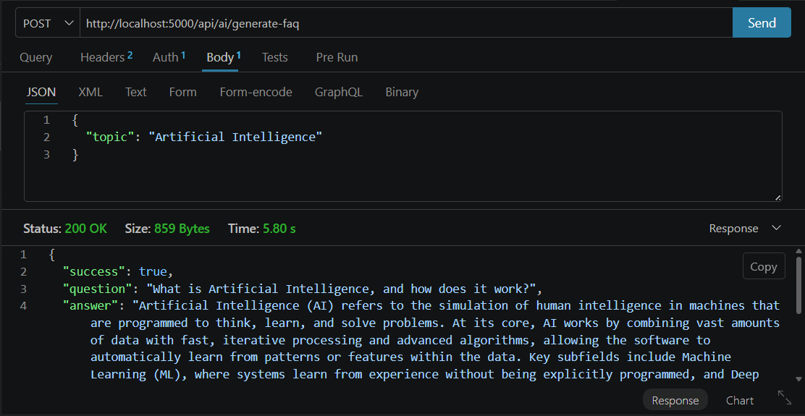

28. Conclusion
The AI FAQ Assistant successfully provides a simple and efficient platform for managing frequently asked questions. It allows users to add, view, update, and delete FAQs while using Google Gemini AI to generate relevant answers. Node.js and Express.js handle the backend, MongoDB stores the data, and JWT with bcrypt provides secure authentication. The project demonstrates how Artificial Intelligence can be integrated with a web application to make information access faster and easier. Overall, the system provides a strong foundation that can be further improved with features such as better AI responses, an improved user interface, and support for multiple languages.

Demo Video Link: https://drive.google.com/file/d/1Fq7I2GAU351WAxmk6PL0DskK2d4Gxkht/view?usp=drivesdk

